**OhioGuidestone Information Guidance for Student Interns (& Supervisors)  
(v.10.2023)**

**Guidance Document Contents**

**OhioGuidestone Information Guidance for Student Interns (& Supervisors)** 2

**Intern Evaluation Project Information Form & Agreement** 2

**Intern Project Restrictions & Limitations** 4

**Project Designs & Details Allowed** 6

**Expectations of Supervisors** 9

**Links and Resources** 10

# **OhioGuidestone Information Guidance for Student Interns (& Supervisors)**

This document is connected with the agency’s research policy as well as distinct policies on research and evaluation activities (please see Policy Stat for full policy and procedures).

This document is to guide interns on the allowed type of evaluation activities. Every intern is required to complete an Intern Evaluation Project Information Form & Agreement, and will need to discuss their project and receive guidance and oversight from their assigned supervisor.

Included in this document are:

* **Intern Evaluation Project Information Form & Agreement Overview**
* **Project Restrictions & Limitations Overview**
* **Project Designs & Details Allowed Overview**
* **Expectations of Interns & Supervisors Overview**

## **Intern Evaluation Project Information Form & Agreement**

All student interns are required to submit information about their coursework-related evaluation project. An online form will collect basic information from students at least **two (2) weeks before submitting details of a possible project at OhioGuidestone –or- expecting to start project.** Many student intern projects are introduced at the beginning of a course, and the final assignment or project is due at the end of a semester, or even subsequent semesters or before graduation. The [Intern Evaluation Project Information Form & Agreement](https://research.ohioguidestone.org/study/?page_id=1360&preview=true) allows students to provide basic initial information so that OhioGuidestone can be prepared to confirm if students’ project ideas can, or cannot be conducted- as well as prepares us to best support your learning goals while at OhioGuidestone.

To start, each student intern is asked to provide:

* Basic school & class information
* Evaluation assignment details (i.e. upload class assignment or syllabus)
* Intentions with data and report at end of coursework/project

The following details may not be known yet, but will be required when available (or you might provide this information with the expectation that details might change):

* Evaluation question
* Program/Project want to evaluate
* Sample/Target of interest

All of these details will be required for evaluation projects at some point, and you are expected to provide updates (using the [Update Intern Evaluation Project Form](https://research.ohioguidestone.org/study/?page_id=1365&preview=true)) to your form and communicate with your assigned supervisor. **No data collection can begin without these details being submitted, reviewed and approved.**

Lastly, you will be required to:

* Submit your final assignment/project (e.g. paper, presentation).

OhioGuidestone is working to create a Student Evaluation Showcase to celebrate your learning goals related to research and evaluation competencies. More information is forthcoming (as of Fall 2023).

The last section of the initial form has a space asking you to sign and confirm your agreement to the agency policies and procedures, and requirements listed on this document. These are summarized here in “I understand” statements:

* The [Initial Intern Evaluation Project Information Form](https://research.ohioguidestone.org/study/?page_id=1360&preview=true) needs to be completed at least 2 weeks before submitting details of a possible project to be done at OhioGuidestone to my professor -or- at least 2 weeks before expecting to start the project.
* My project needs to conform to OhioGuidestone policies and procedures for research, evaluation and student intern projects.
* That I need to review and abide by the expectations presented in the Student Intern Guidance.
* That I need to provide updates to my project by completing the [Update Intern Evaluation Project Form](https://research.ohioguidestone.org/study/?page_id=1365&preview=true).
* That no data collection can begin without all basic details (on form and listed above) being submitted, reviewed and approved.
* That all project activities, especially data collection and storage must follow OhioGuidestone and regulatory requirements for confidentiality, privacy, and protection of data.
* That my supervisor and specific OhioGuidestone staff (i.e. Internship Coordinator, Applied Clinical Sciences & Research, Quality Department) will provide oversight and support of my project -and- will have access to the information shared in this form (and update forms).
* That I need to submit my final project/presentation.

## **Intern Project Restrictions & Limitations**

The following are restrictions (‘no’s’) and limitations (needs further review for possibility) for student intern projects. All student intern evaluation projects need to be reviewed, approved, and have oversight from an assigned supervisor (or other appropriate designee).

* **Restrictions for Research for Bachelors & Masters & Doctoral Levels**
  + Per OhioGuidestone policy, no research activity (including quasi-research) is allowed without prior and proper review and approval. All research activity needs to be presented to through the Institute of Family & Community Impact’s Institutional Review Board (email [research@ohioguidestone.org](mailto:research@ohioguidestone.org)). Currently, research activities are not permitted for student intern projects.
  + Bachelors and Master’s level student interns interested in participating in research activities may be provided the opportunity to engage in ongoing research activities at the agency.
  + Doctoral level students may also be provided the opportunity to engage in ongoing research activities, or propose a research project directly related to their agency role and ongoing research priorities and frameworks (subject to review and approval).
* **No Big/Large Data Set Requests**
  + Student interns needing large datasets may be provided the opportunity to engage in ongoing agency research or data analytical activities. Otherwise, student interns needing large datasets will be directed to public dataset sources (assistance can be provided).
* **No Personnel Studies**
  + Per OhioGuidestone procedure, no research activity involving OhioGuidestone personnel (board, staff, interns, volunteers, etc.) is permitted for student intern projects. Exceptions may be considered for student interns within business, finance, HR or organizational development studies on a case-by-case basis, and related to ongoing agency projects and priorities.
* **No Cost Analysis**
  + Except for finance or business (or comparable field) student interns, no program evaluation projects utilizing cost analysis designs are not permitted for student intern projects.
* **No Satisfaction-related Projects**
  + Student interns are not permitted to use satisfaction data or center satisfaction of OhioGuidestone personnel (board, staff, interns, volunteers, etc.), funders, partners, or clients as their program evaluation project.
  + Student interns are permitted to do self-studies, and therefore this is the only exception.
* **No Reporting or Presenting Beyond Project Scope**
  + Approved student intern projects are limited to their coursework’s requirements for submitted assignments, reports, or class presentations. No reporting or presenting beyond coursework requirements are allowed without further review and approval. (Note: some project evaluation activities do rise to the level of research (e.g. generalizable information; new research study) and will be governed as such- see research policies/procedures.)
* **Limitations on Specific Communities, Groups and/or Cultural Identities**
  + Research regulations, along with many evaluation best practices, restricts access to specific communities, groups or cultural identities- or advises certain approaches to most limit risk and most enhance benefit.
  + The intentions for these restrictions are to limit harm and hurt directly to people (personnel, clients, community members) as well as to limit: increased stigma and discrimination, reinforcement of stereotypes, and reification of social violence.
  + At OhioGuidestone, student interns evaluation projects seeking to include or evaluate within our PROTECT program participants, domestic/intimate partner violence program participants, youth residential treatment center clients, foster care families, refugee communities, or Amish/Mennonite communities without will require more in-depth review, and possibly will not be allowed.

## **Project Designs & Details Allowed**

This flow chart is designed to help student interns brainstorm and inform their evaluation project designs and details that are allowed. Details for certain allowances and expectations are detailed below.

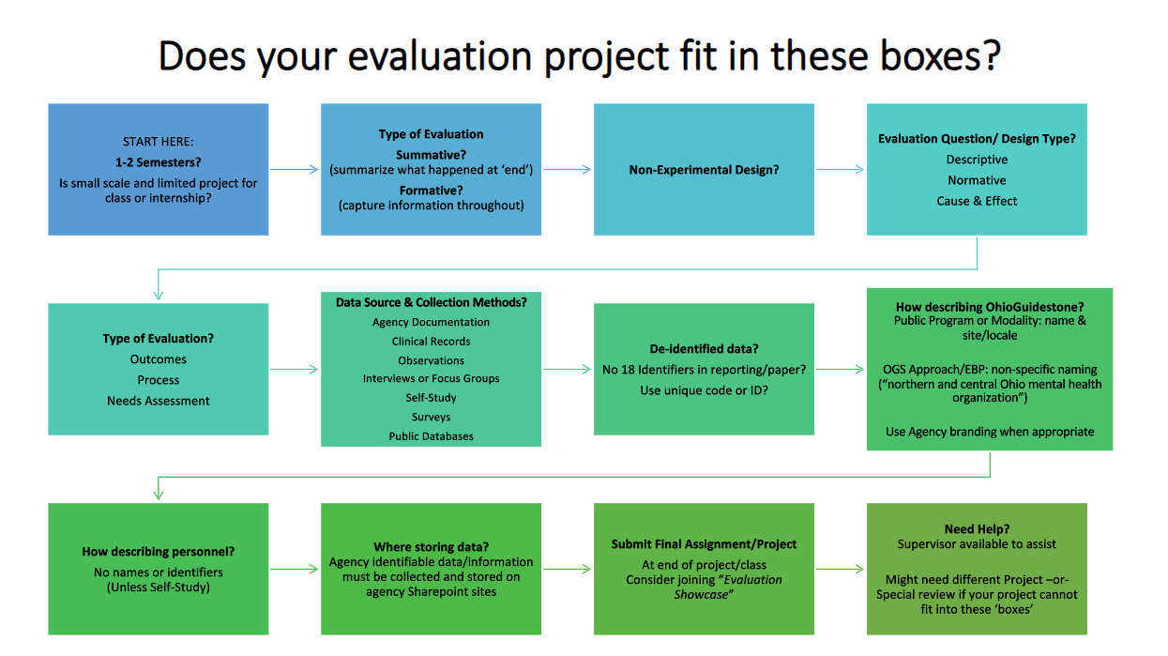

**Allowances & Expectations of Student Intern Program Evaluation Projects**

* **Connected to coursework over 1-2 semesters**
  + If project is not for school, needs to partner with IFCI to be efficient and responsive to agency priorities and capacity​
  + If not needs more than 1-2 semester*, will re-do Evaluation Project Information Form & Agreement​
  + Students need to have S.M.A.R.T. goals for their evaluation project​
    - Specific, Measurable, Achievable, Realistic, Time bound​
  + *If part-time student: will work with their semester duration
* **Summative or Formative Evaluation Allowed**
  + Summative- capture information for time of project or program, and summarize at end​
    - “Did the program achieve it’s intended outcomes?”​
  + Formative- capture information and evaluate/analyze throughout project or program​
    - “What is working well, or not working so well from group participants’ perspective?”​
    - “Is the program proceeding as planned?”​
* **Only Non-Experimental Designs**
  + No Randomized Control Trials (RCTs), Quasi Experimental
* **Evaluation Design or Question Type**
* **Descriptive**: What|Who|Where|How-like questions​
  + *“What percent of clients had decreased depressive symptoms after 10 weekly group sessions?”*​
  + *“What is the PROM completion rate for residential clients?”*​
* ​**Normative**: What is –vs- should​
  + *Did clinical interns achieve learning goals from learning contract?*​
  + *To what extent was target of quarterly PROMs completed?*​
  + *To what extent was target of weekly CBT+ homework completed?*​
  + *To what extent was target of 75% attendance achieved?*​
* ​**Cause & Effect**: Results achieved of doing something​
  + Captures: Impact, Pre/Post changes, or other differences in outcomes due to a specific intervention or activity​
  + *After therapy sessions in client’s native language, do they have improved attendance rates?*​
  + *In the week after Triple P sessions, do parents report less temper tantrums?*​
  + *After 6 weekly behavioral health sessions, did clients report lower stress?*​
  + *Did clients have better school attendance after 6 weekly group sessions with the school counselor?*​
* **Type or Focus of Evaluation**
* **Outcomes**: ​
* Changes (+ or - )​
* Individual, group or society level​
* Knowledge, attitudes, capabilities, behaviors, economic/health/social/environmental conditions​
* Summative or formative​

​**Process**: ​

* Evaluates efficiency, content, outputs or delivery​
* Summative or formative​
* ​**Needs Assessment**: ​
* Accurate, thorough picture of strengths and weaknesses or resources…to see if need or problem present- and how to address​
* ​**NOT** Permitted​
* Cost Analysis: unless a policy or business field intern​
* Satisfaction: not allowed at internship level​
* **Data Source & Collection Methods**
* **Agency documentation**:  what is readily available via dashboards or program evaluation reports​
* ​**Clinical records**: for own clientor if work with agency evaluation teams with a specific  request​​
* **Observations**: own client only, group by-stander​​
* **Interviews or Focus Group**:  own client only (or if work with agency evaluation teams)​​
* **Self-Study**​​
* **Surveys**: own client only (or if work with agency evaluation teams)​
* Survey needs to be reviewed and approved by supervisor before sent​
* Use Microsoft Forms (OGS's platform; keeps data in compliance)​
* Requires clear statement that is a part of a student/class requirement; not agency process or program; and clear affirmation what are/aren’t doing with information​​
* **Public Databases**​
* Includes agency’s Annual Report​
* **De-Identified Data**
* **No use of 18 identifiers in report/paper**
  + **Learn more:** [**Guidance Regarding Methods for De-identification of Protected Health Information in Accordance with the Health Insurance Portability and Accountability Act (HIPPA) Privacy Rule**](https://www.hhs.gov/hipaa/for-professionals/privacy/special-topics/de-identification/index.html)(link valid 10.2.2023)
* **Must use a unique code or ID**
* **Store all data on OhioGuidestone Servers (e.g. Sharepoint)**
* Agency identifiable data/information must be collected and stored on agency Sharepoint sites​
* **Submit Final Assignment/Project**
* Also consider joining the Evaluation Showcase (more information TBD)
* **Get HELP!**
* Supervisor is available to assist and point to additional resources
* **Project doesn’t fit into these categories?**
* Willneed a different project or special review if your project cannot fit into these boxes. Speak with supervisor and/or email [research@ohioguidestone.org](mailto:research@ohioguidestone.org)

## **Expectations of Supervisors**

Supervisors of student interns have access to a training resource that delineates the difference between research and evaluation, as well as provides a supervisor specific overview of how to supervise and support student interns’ program evaluation projects. (This document is listed in the Links & Resources section at the end of this document.)

Here is an overview of expectations of supervisors:

* **Review Student-Intern Evaluation Project Information Form & Agreement**​
* Will receive an emailed copy​
* Confirm agreement and alignment​

​

* **Confirm understanding of Student-Intern’s:**​
* Evaluation question​
* Information needed for project​
* Help with data collection

​

* **Confirm review and alignment:**​
* Agency policy & procedures​
* Licensure professional competencies & ethics​

​

* **Confirm ability to oversee project**​
* Understanding of student expectations​
* Align practice with Core Competencies for Licensure field​

​

* **Support project**​
* Ask about progress​
* Review updates when have more details of project​
* Connect to internal supports (e.g. evaluation, research, quality team members)​

# **Links and Resources**

[Student Intern Evaluations Project Page](https://research.ohioguidestone.org/study/student-intern-evaluation-projects/)

[Initial Intern Evaluation Project Form & Agreement](https://research.ohioguidestone.org/study/?page_id=1360&preview=true)

[Update Intern Evaluation Project Form](https://research.ohioguidestone.org/study/student-intern-evaluation-projects/updated-intern-evaluation-project-form/)

Supervisor Training PowerPoint- see “Intern Support Team” within Teams

“Supporting & Supervising Student-Intern Evaluation & Research Coursework Projects​​” (Adam Peltier & Brittany R. Pope, September/October 2023)

Resources

[Evaluation Questions: A Guide to Designing Effective Evaluation Questions](https://www.evalcommunity.com/career-center/evaluation-questions/) (link valid 10.3.2023)

[Center for Disease Control & Prevention (CDC): Program Evaluation](https://www.cdc.gov/evaluation/index.htm) (link valid 10.3.2023)

[Evaluating Program and Practice Effectiveness](https://www.childwelfare.gov/topics/management/effectiveness/) (link valid 10.3.2023)

[Research & Statistics for Understanding Social Work Interventions](https://ohiostate.pressbooks.pub/swk3402/chapter/module-1-chapter-3-practice-evaluation-as-evidence/) (link valid 10.3.2023)